**Assignment 1. Data Lakehouse with Snowflake**

Contents

I. Part 1. Overview of the project: 2

II. Part 2. Data integration: 2

III. Part 3: Data Cleaning: 12

IV. Part 3: Data analysis: 15

V. Part 4: Business Question: 45

1. **Part 1. Overview of the project:**

The main objective of the project is to analyze the YouTube data to gain insight into a content strategy for launching a successful YouTube Channel. The analysis will comprise four main parts. This first part is the summary of the project content. Next, the data integration (**part 1**) introduces steps to upload data into Snowflake from Azure Storage. This phase ensures that the dataset is ready for analysis. In **part 2**, data cleaning will be performed to prepare the final data table. Subsequently, the data analysis will be carried out in **part 3.** This part will analyze and visualize the results obtained from part 2 to explore YouTube trends across different countries and categories. **Part 4** then will utilize the results from previous parts to answer the questions: “*If you were to launch a new Youtube channel tomorrow, which category (excluding “Music” and “Entertainment”) of video will you be trying to create to have them appear in the top trend of Youtube? Will this strategy work in every country?*”.

Overall, the project results will highlight insights into YouTube trends and give some recommendations, which can be a foundation for informed content creation and promotion strategies in launching a new YouTube Channel.

1. **Part 2. Data integration**:

This section outlines a process to upload and integrate data into Snowflake from Azure Storage. The main steps involve creating container, uploading files, establishing connections, transforming data into Snowflake by external tables, and finally consolidating data into a single table for analysis. Below are the details for each of these steps.

1. Upload data into azure storage:
2. Create a new container:

Create a new container called assignment1 in the storage account on the Azure portal

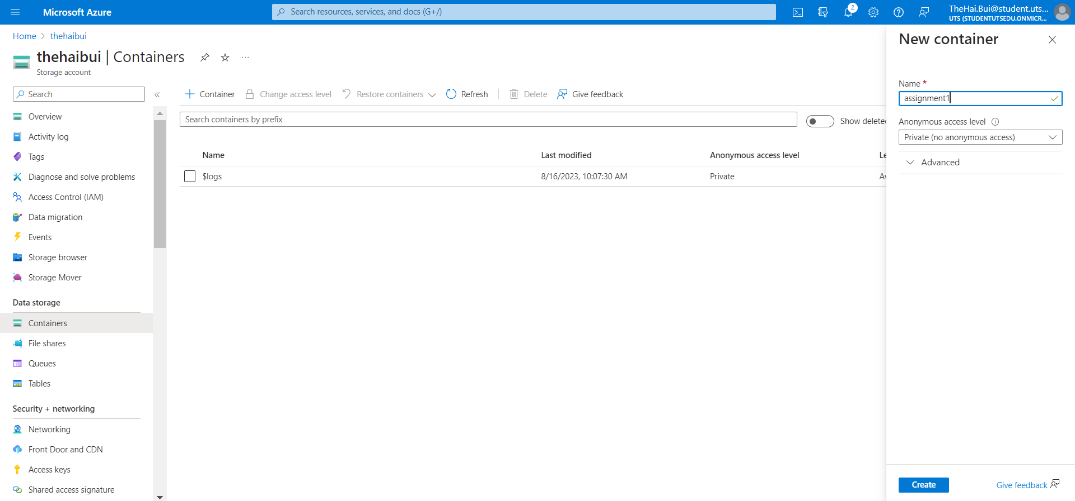

1. Upload json file

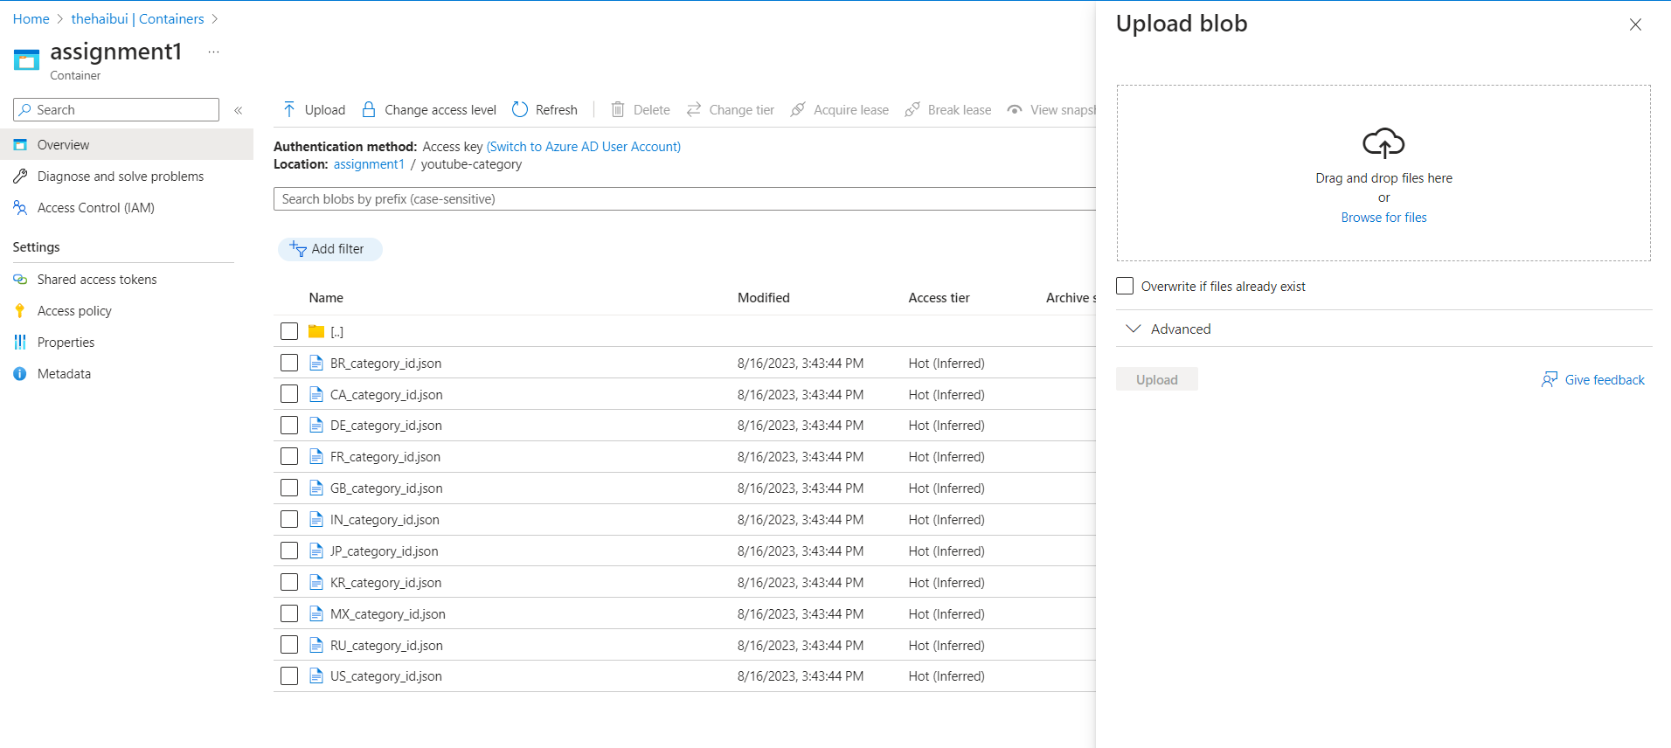

1. Upload csv file

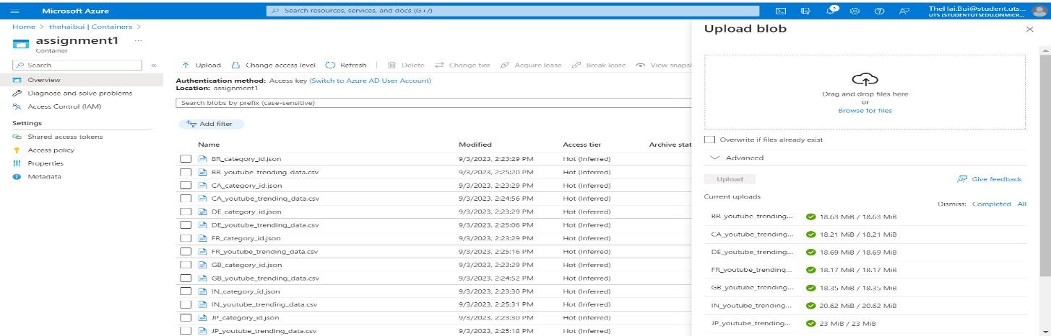

1. Upload data from azure storage to snowflake
2. Create the database `assignment_1`:

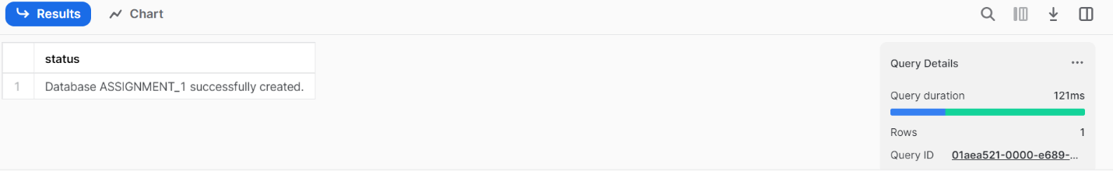

1. Switch to the database `assignment_1`:

1. Create a storage integration called `azure_assginment_1`

1. Use the `DESC STORAGE INTEGRATION` command to retrieve the `AZURE_CONSENT_URL`

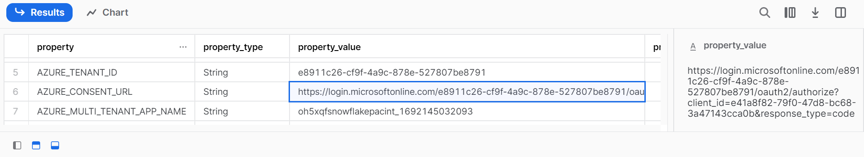

(https://login.microsoftonline.com/e8911c26-cf9f-4a9c-878e-527807be8791/oauth2/authorize?client_id=e41a8f82-79f0-47d8-bc68-3a47143cca0b&response_type=code)

1. Login to the account with the consent url:

Its login successfully to the account

1. Go to your storage account screen on the Azure Portal, press on the Access Contral tab and add a role assignment:

1. Select the `***Storage Blob Data Owner***` then add a new member with `***snowflakepacint***` *(Step 2d)* and finalize the role creation:

1. Ingest the data as external tables on Snowflake:
2. Create a Stage called ‘stage_assignment_1’:

1. Use the command `list` to list all the files inside your stage:

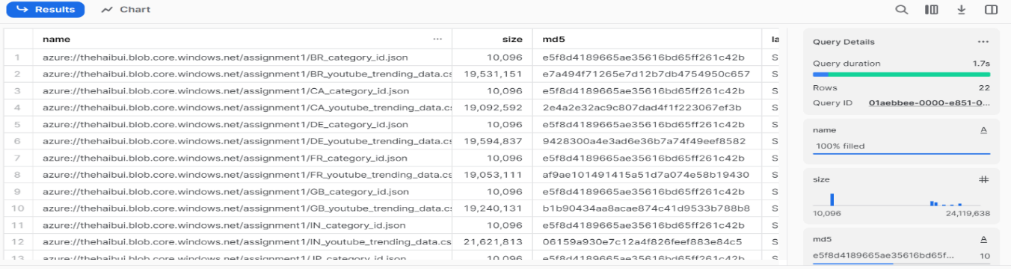

1. Ingest the data as external tables on Snowflake:

* *Create a file format called `file_format_csv` with*:

***(* TYPE = 'CSV'***

***\* FIELD_DELIMITER = ','***

***\* SKIP_HEADER = 1***

***\* NULL_IF = ('\\N', 'NULL', 'NUL', '')***

***\* FIELD_OPTIONALLY_ENCLOSED_BY = '"'***)

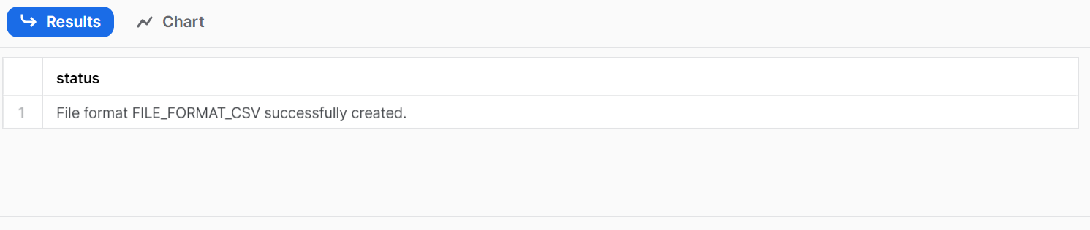

* Create an external table called `ex_table_youtube_trending` with:

***(* LOCATION = @stage_assignment_1***

***\* FILE_FORMAT = file_format_csv***

***\* PATTERN = 'FR_youtube_trending_data.csv')***

* Display the ex_table_youtube_trending:

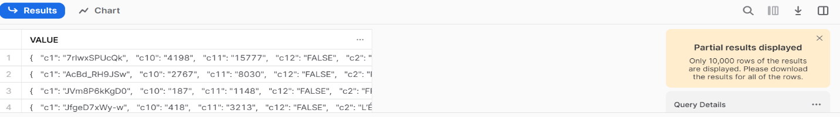

* Create an external table called `ex_table_youtube_category` with

***(* LOCATION = @stage_assignment_1***

***\* FILE_FORMAT = file_format_csv***

***\* PATTERN =’ .*_category_id[.]json’***)

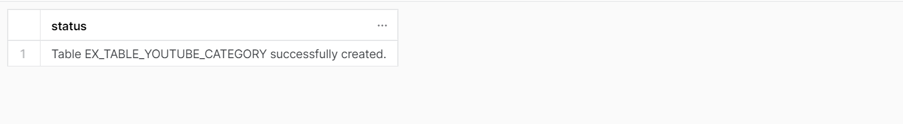

* Display the ex_table_youtube_category:

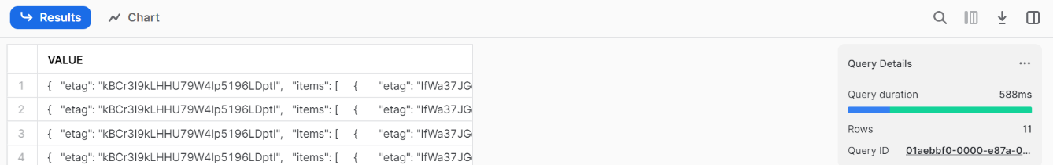

1. Transfer the data from external tables into tables:
2. For trending data create a table called “table_youtube_trending”:

* Display the first 2 rows of the ex_table_youtube_trending

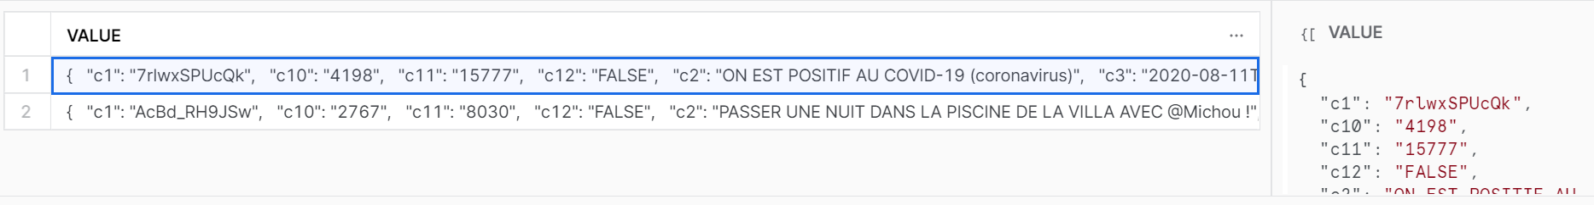

Here is the value of the first rows:

***{ "c1": "7rlwxSPUcQk", "c10": "4198","c11": "15777","c12": "FALSE", "c2": "ON EST POSITIF AU COVID-19 (coronavirus)", "c3": "2020-08-11T16:00:31Z","c4":"UCpWaR3gNAQGsX48cIlQC0qw", "c5": "Tibo InShape", "c6":"17","c7": "2020-08-12T00:00:00Z","c8": "1943013","c9": "165557"}***

* Recreate `ex_table_youtube_trending` with a new statement containing the correct data type and name for each above column.

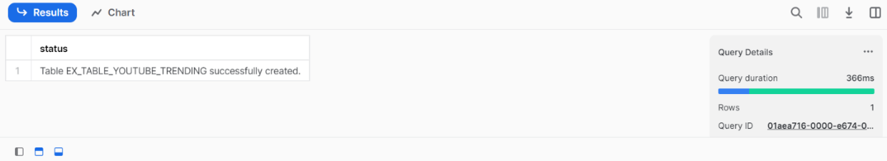

* Create table_youtube_trending by transfering data from the table ex_table_youtube trending

* Display table_youtube_trending

1. For category data create a table called “table_youtube_category”:

* Display the first 2 rows of the ex_table_youtube_category:

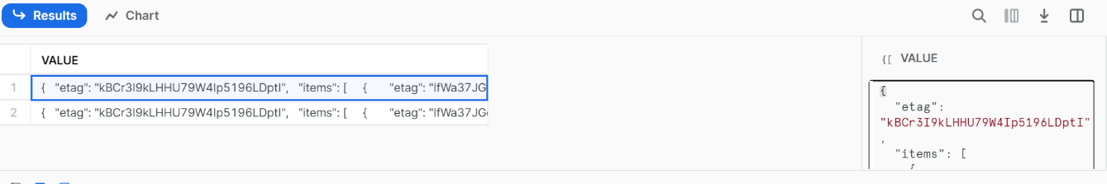

* Copy the value and paste it into the website: <https://codebeautify.org/jsonviewer>

* Use the `lateral flatten` function to retrieve the field `categoryid` and ‘category_title’ from `ex_table_youtube_category` and limit to 10 rows

* Query the metadata field `metadata$filename` from `ex_table_youtube_category` to retrieve the filename:

* Use the split_part function on `metadata$filename` to retrieve the country name from the filename.

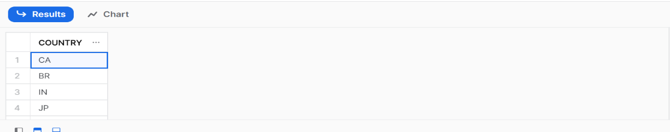

* Recreate `table_youtube_category` with a new statement containing the correct data type and name for each column.

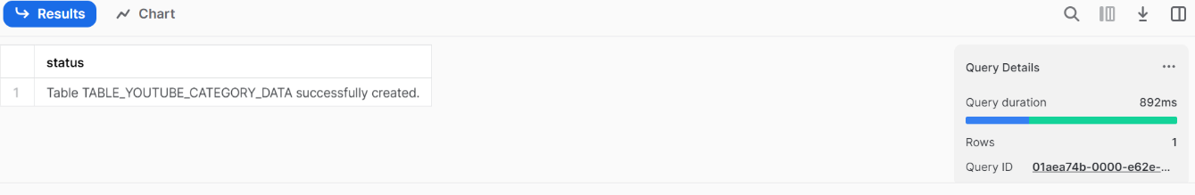

* Display `table_youtube_category`

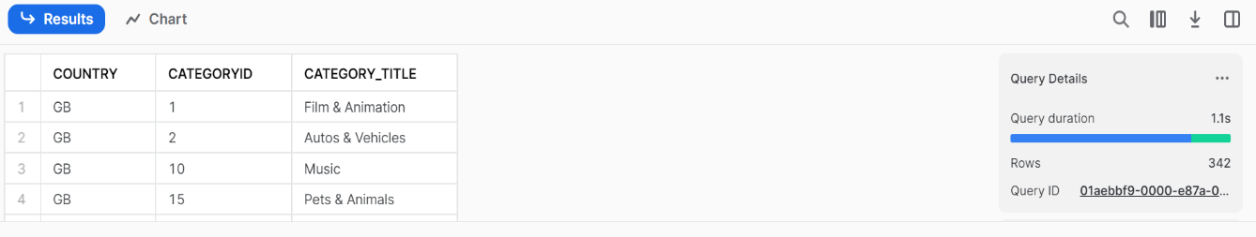

1. Create a final table called “table_youtube_final” by combining “table_youtube_trending” and “table_youtube_category” on country and categoryid (be careful to not lose any records), while adding a new field called “id” by using the “UUID_STRING()” function

* Display `table_youtube_final

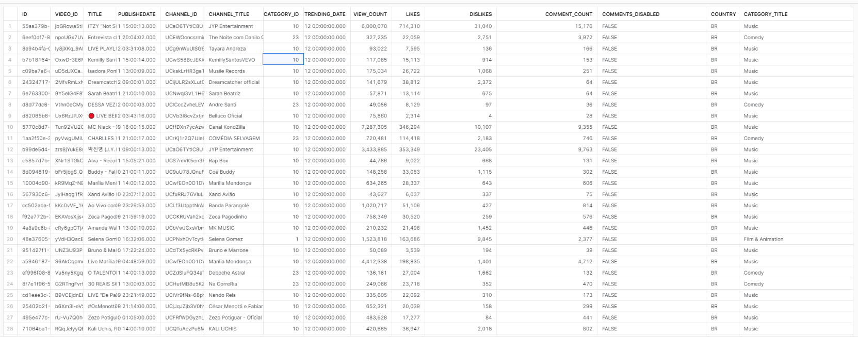

1. **Part 3: Data Cleaning:**

Next, we will dive into the data cleaning task to ensure the quality and accuracy of the dataset. This phase will involve SQL queries and operations to address various aspects of data integrity. Through this task, we aim to enhance the data quality and prepare for further analysis and insights.

In “table_youtube_category” which category_title has duplicates if we don’t take into account the categoryid?

|  |
| --- |
| CATEGORY_TITLE |
| Film & Animation |
| Sports |
| Short Movies |
| Gaming |
| Videoblogging |
| People & Blogs |
| Comedy |
| Shorts |
| Trailers |
| Travel & Events |
| Horror |
| Sci-Fi/Fantasy |
| News & Politics |
| Howto & Style |
| Education |
| Science & Technology |
| Drama |
| Classics |
| Family |
| Movies |
| Music |
| Thriller |
| Shows |
| Pets & Animals |
| Anime/Animation |
| Documentary |
| Foreign |
| Autos & Vehicles |
| Entertainment |
| Action/Adventure |

In “table_youtube_category” which category_title only appears in one country?

|  |
| --- |
| CATEGORY_TITLE |
| Nonprofits & Activism |

In “table_youtube_final”, what is the categoryid of the missing category_title?

|  |
| --- |
| CATEGORY_ID |
| 29 |

Update the table_youtube_final to replace the NULL values in category_title with the answer from the previous question.

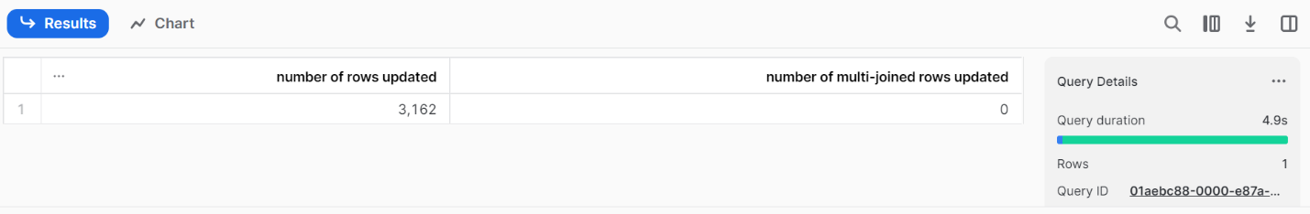

In “table_youtube_final”, which video doesn’t have a channeltitle?

|  |  |
| --- | --- |
| ID | ebd82ecd-e9e7-41be-a9dc-0b2a7b7adc6e |
| VIDEO_ID | 9b9MovPPewk |
| TITLE | Kala Official Teaser | Tovino Thomas | Rohith V S | Juvis Productions | Adventure Company |
| PUBLISHEDATE | 2021-01-21T12:30:29Z |

Delete from “table_youtube_final“, any record with video_id = “#NAME?”. The “table_youtube_final“ contains duplicates with the same video_id, country and trending_date however their metrics (likes, dislikes, etc..) can be different. We can assume that the highest number of view_count will be the record to keep when we have duplicates.

|  |
| --- |
| number of rows deleted |
| 14619 |

Create a new table called “table_youtube_duplicates” containing only the “bad” duplicates by using the row_number() function.

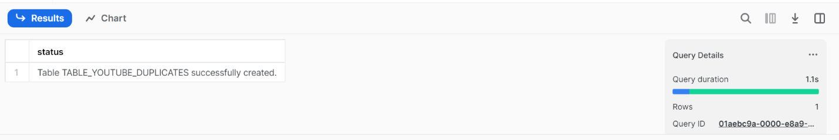

Delete the duplicates in “table_youtube_final“ by using “table_youtube_duplicates”.

Count the number of rows in “table_youtube_final“ and check that it is equal to 1,123,017 rows.

1. **Part 3: Data analysis**:

In this part, we will explore the dataset to gain more meaningful insights by answering specific questions. This task will enable us to make informed decisions and draw profound conclusions.

1. What are the 3 most viewed videos for each country in the “Sports” category for the trending_date = ‘'2021-10-17'’. Order the result by country and the rank, e.g:

|  |  |  |  |  |
| --- | --- | --- | --- | --- |
| COUNTRY | TITLE | CHANNEL_TITLE | VIEW_COUNT | RK |
| BR | BRASIL 4 X 1 URUGUAI | MELHORES MOMENTOS | 12Âª RODADA ELIMINATÃ“RIAS DA COPA | ge.globo | Ge | 4562725 | 1 |
| BR | MAIS TRÃŠS GOLS DE CRISTIANO RONALDO! PORTUGAL 5 X 0 LUXEMBURGO | MELHORES MOMENTOS | TNT Sports Brasil | 2053005 | 2 |
| BR | â™« NEYMAR TÃ DE VOLTA!! E A DUPLA COM RAPHINHA DECOLOU! | ParÃ³dia Mulher Kamasutra 2 - MC Livinho | FutParÃ³dias | 814491 | 3 |
| CA | Sore loser! An idiot! Tyson Fury reveals what was said between him & Deontay Wilder after huge win | BT Sport Boxing | 6913800 | 1 |
| CA | World's Smallest TV | OT 30 | Dude Perfect | 6222811 | 2 |
| CA | Eliminatorias | Brasil 4-1 Uruguay | Fecha 12 | CONMEBOL | 4354963 | 3 |
| DE | Eliminatorias | Brasil 4-1 Uruguay | Fecha 12 | CONMEBOL | 4354963 | 1 |
| DE | Lesnar returns for the Universal Title Match Contract Signing with Reigns: SmackDown, Oct. 15, 202.. | WWE | 2872431 | 2 |
| DE | Timo Werner schieÃŸt DFB-Team zur WM: Nordmazedonien - Deutschland 0:4 | European Qualifiers | DAZN | DAZN LÃ¤nderspiele | 1793189 | 3 |
| FR | Lesnar returns for the Universal Title Match Contract Signing with Reigns: SmackDown, Oct. 15, 202.. | WWE | 2872431 | 1 |
| FR | Le film de la finale de l'UEFA Nations League, Equipe de France I FFF 2021 | FÃ©dÃ©ration FranÃ§aise de Football | 1504302 | 2 |
| FR | Espagne 1-2 France, le reÌsumeÌ - Finale UEFA Nations League I FFF 2021 | FÃ©dÃ©ration FranÃ§aise de Football | 1454288 | 3 |
| GB | Sore loser! An idiot! Tyson Fury reveals what was said between him & Deontay Wilder after huge win | BT Sport Boxing | 6913800 | 1 |
| GB | World's Smallest TV | OT 30 | Dude Perfect | 6222811 | 2 |
| GB | BRASIL 4 X 1 URUGUAI | MELHORES MOMENTOS | 12Âª RODADA ELIMINATÃ“RIAS DA COPA | ge.globo | Ge | 4562725 | 3 |
| IN | Roman Reigns vs. Brock Lesnarâ€“ Road to WWE Crown Jewel: WWE Playlist | WWE | 2482492 | 1 |
| IN | IND v AUS | 2016 T20WC | Hindi Highlights | ICC | 2363322 | 2 |
| IN | ICC Men's T20 World Cup 2021: Buy 1 Break 1 Free Offer | Star Sports | 2262739 | 3 |
| JP | ã€ã‚¨ã‚°ã„ã€‘ãƒ†ã‚£ãƒ¢ãƒ³ãƒ‡ã‚£é«˜å²¸ è¡æ’ƒå¼¾ #shorts | ãƒ†ã‚£ãƒ¢ãƒ³ãƒ‡ã‚£ãƒ™ãƒ¼ã‚¹ãƒœãƒ¼ãƒ«TV | 2452684 | 1 |
| JP | ã€LIVEã€‘ãƒ‰ãƒ©ãƒ•ãƒˆä¼šè­°é€Ÿå ±ã‚’è±ªè¯ã‚²ã‚¹ãƒˆã¨ä¸€ç·’ã«è¦‹å®ˆã‚ã†ï¼ã€ã‚¹ãƒãƒŠãƒ“ãƒ‰ãƒ©ãƒ•ãƒˆé€Ÿå ±è¦‹ãªãŒãƒ©ã‚¤ãƒ–ã€‘ | ã‚¹ãƒãƒ¼ãƒ„ãƒŠãƒ“å…¬å¼ | 1075850 | 2 |
| JP | ã€ãƒã‚¤ãƒ©ã‚¤ãƒˆãƒ»å®Ÿæ³ã€‘Wæ¯ã‚¢ã‚¸ã‚¢æœ€çµ‚äºˆé¸ã€€æ£®ä¿ã‚¸ãƒ£ãƒ‘ãƒ³ã€çµ¶ä½“çµ¶å‘½ã®å¤§ä¸€ç•ªï¼é¦–ä½ã‚ªãƒ¼ã‚¹ãƒˆãƒ©ãƒªã‚¢ã‚’æ’ƒç ´ï¼(2021å¹´10æœˆ12æ—¥) | ANNnewsCH | 902379 | 3 |
| KR | ë°°í‹€ë¡œì–„ ì‹¤ì‚¬íŒ. ìƒì¡´ ê²©íˆ¬ ì„œë°”ì´ë²Œ l íŒŒì´íŠ¸ í´ëŸ½ EP.1 | KoreanZombie ì½”ë¦¬ì•ˆì¢€ë¹„ | 3182863 | 1 |
| KR | [21/22 PL] 7R í† íŠ¸ë„˜ vs ì•„ìŠ¤í†¤ ë¹Œë¼ MVP ì†í¥ë¯¼ | SPOTV | 2685339 | 2 |
| KR | ì‹¬ì„í¬ëŠ” ìµœë¯¼ì •ì„ ê³ ì˜ë¡œ ë°©í•´í–ˆë‚˜? ë‹¹ì‹œ ê²½ê¸° ìž¥ë©´ê³¼ ì¸í„°ë·°ë¥¼ ë“¤ì—¬ë‹¤ë´¤ìŠµë‹ˆë‹¤! / ìŠ¤í¬ì¸ ë¨¸ê·¸ | ìŠ¤í¬ì¸ ë¨¸ê·¸ - SPORTSMUG | 1687921 | 3 |
| MX | Race Highlights | 2021 Turkish Grand Prix | FORMULA 1 | 5165706 | 1 |
| MX | Eliminatorias | Brasil 4-1 Uruguay | Fecha 12 | CONMEBOL | 4354963 | 2 |
| MX | Argentina 3-0 Uruguay I Eliminatorias a Catar 2022 | TyC Sports | 2794195 | 3 |
| RU | Highlights: Watford 0-5 Liverpool | Mane, Salah & a Firmino hat-trick for sensational Reds | Liverpool FC | 1705824 | 1 |
| RU | Ð¢-34 VS Ð±Ð¾ÐµÑ† UFC. Ð¥Ð°Ð´Ð¸Ñ VS ÐÐ½Ð´Ñ€ÑŽÑˆÐºÐ¾. ÐÐ°Ð·Ð¸Ñ€. ÐÑ€Ð¼ÐµÐµÑ† VS ÐÐ¸Ð»Ð¾Ð². ÐœÐ°Ñ€Ð°Ñ‚ Ð‘Ð°Ð»Ð°ÐµÐ² Ð½Ð° Ð¥Ð°Ñ€Ð´ÐºÐ¾Ñ€Ðµ. 1/8 Ð³Ñ€Ð°Ð½-Ð¿Ñ€Ð¸ | HFC MMA | 1203498 | 2 |
| RU | Knockout Of The Year?! Superbon SHOCKS Giorgio Petrosyan ðŸ˜± | ONE Championship | 1020267 | 3 |
| US | Dice Stacks from $1 to $100 | That's Amazing Shorts | 69866143 | 1 |
| US | FIGHT HIGHLIGHTS | Anthony Joshua vs. Oleksandr Usyk | DAZN Boxing | 8639065 | 2 |
| US | Sore loser! An idiot! Tyson Fury reveals what was said between him & Deontay Wilder after huge win | BT Sport Boxing | 6913800 | 3 |

1. For each country, count the number of distinct video with a title containing the word “BTS” and order the result by count in a descending order, e.g:

|  |  |
| --- | --- |
| COUNTRY | CT |
| KR | 331 |
| RU | 230 |
| US | 179 |
| CA | 173 |
| MX | 164 |
| DE | 162 |
| JP | 152 |
| IN | 149 |
| GB | 145 |
| BR | 116 |
| FR | 108 |

1. For each country, year and month (in a single column), which video is the most viewed and what is its likes_ratio (defined as the percentage of likes against view_count) truncated to 2 decimals. Order the result by year_month and country.

|  |  |  |  |  |  |  |
| --- | --- | --- | --- | --- | --- | --- |
| COUNTRY | YEAR_MONTH | TITLE | CHANNELTITLE | CATEGORY_TITLE | VIEW_COUNT | LIKES_RATIO |
| BR | 8/1/2020 | BTS (방탄소년단) 'Dynamite' Official MV | Big Hit Labels | Music | 244507902 | 6.52 |
| CA | 8/1/2020 | BTS (방탄소년단) 'Dynamite' Official MV | Big Hit Labels | Music | 232649205 | 6.76 |
| DE | 8/1/2020 | BTS (방탄소년단) 'Dynamite' Official MV | Big Hit Labels | Music | 219110491 | 7.06 |
| FR | 8/1/2020 | BTS (방탄소년단) 'Dynamite' Official MV | Big Hit Labels | Music | 232649205 | 6.76 |
| GB | 8/1/2020 | BTS (방탄소년단) 'Dynamite' Official MV | Big Hit Labels | Music | 208581468 | 7.31 |
| IN | 8/1/2020 | BTS (방탄소년단) 'Dynamite' Official MV | Big Hit Labels | Music | 253995993 | 6.34 |
| JP | 8/1/2020 | BTS (방탄소년단) 'Dynamite' Official MV | Big Hit Labels | Music | 262319276 | 6.2 |
| KR | 8/1/2020 | BTS (방탄소년단) 'Dynamite' Official MV | Big Hit Labels | Music | 262319276 | 6.2 |
| MX | 8/1/2020 | BTS (방탄소년단) 'Dynamite' Official MV | Big Hit Labels | Music | 253995993 | 6.34 |
| RU | 8/1/2020 | BTS (방탄소년단) 'Dynamite' Official MV | Big Hit Labels | Music | 183532509 | 8 |
| US | 8/1/2020 | BTS (방탄소년단) 'Dynamite' Official MV | Big Hit Labels | Music | 232649205 | 6.76 |
| BR | 9/1/2020 | BLACKPINK - 'Ice Cream (with Selena Gomez)' M/V | BLACKPINK | Music | 167334429 | 6.86 |
| CA | 9/1/2020 | BLACKPINK - 'Ice Cream (with Selena Gomez)' M/V | BLACKPINK | Music | 184778248 | 6.38 |
| DE | 9/1/2020 | BLACKPINK - 'Ice Cream (with Selena Gomez)' M/V | BLACKPINK | Music | 167334429 | 6.86 |
| FR | 9/1/2020 | BLACKPINK - 'Ice Cream (with Selena Gomez)' M/V | BLACKPINK | Music | 167334429 | 6.86 |
| GB | 9/1/2020 | BLACKPINK - 'Ice Cream (with Selena Gomez)' M/V | BLACKPINK | Music | 176467113 | 6.6 |
| IN | 9/1/2020 | BLACKPINK - 'Ice Cream (with Selena Gomez)' M/V | BLACKPINK | Music | 184778248 | 6.38 |
| JP | 9/1/2020 | BLACKPINK - 'Ice Cream (with Selena Gomez)' M/V | BLACKPINK | Music | 184778248 | 6.38 |
| KR | 9/1/2020 | BLACKPINK - 'Ice Cream (with Selena Gomez)' M/V | BLACKPINK | Music | 184778248 | 6.38 |
| MX | 9/1/2020 | BLACKPINK - 'Ice Cream (with Selena Gomez)' M/V | BLACKPINK | Music | 184778248 | 6.38 |
| RU | 9/1/2020 | 6IX9INE- TUTU (Official Music Video) | Tekashi 6ix9ine | Music | 42054762 | 3.58 |
| US | 9/1/2020 | BLACKPINK - 'Ice Cream (with Selena Gomez)' M/V | BLACKPINK | Music | 184778248 | 6.38 |
| BR | 10/1/2020 | BLACKPINK – ‘Lovesick Girls’ M/V | BLACKPINK | Music | 140685439 | 6.55 |
| CA | 10/1/2020 | BLACKPINK – ‘Lovesick Girls’ M/V | BLACKPINK | Music | 140685439 | 6.55 |
| DE | 10/1/2020 | BLACKPINK – ‘Lovesick Girls’ M/V | BLACKPINK | Music | 124180499 | 7.21 |
| FR | 10/1/2020 | BLACKPINK – ‘Lovesick Girls’ M/V | BLACKPINK | Music | 132678906 | 6.86 |
| GB | 10/1/2020 | BLACKPINK – ‘Lovesick Girls’ M/V | BLACKPINK | Music | 124180499 | 7.21 |
| IN | 10/1/2020 | BLACKPINK – ‘Lovesick Girls’ M/V | BLACKPINK | Music | 140685439 | 6.55 |
| JP | 10/1/2020 | BLACKPINK – ‘Lovesick Girls’ M/V | BLACKPINK | Music | 152325542 | 6.18 |
| KR | 10/1/2020 | BLACKPINK – ‘Lovesick Girls’ M/V | BLACKPINK | Music | 161416953 | 5.91 |
| MX | 10/1/2020 | BLACKPINK – ‘Lovesick Girls’ M/V | BLACKPINK | Music | 152325542 | 6.18 |
| RU | 10/1/2020 | BLACKPINK – ‘Lovesick Girls’ M/V | BLACKPINK | Music | 105309895 | 8.2 |
| US | 10/1/2020 | BLACKPINK – ‘Lovesick Girls’ M/V | BLACKPINK | Music | 140685439 | 6.55 |
| BR | 11/1/2020 | BTS (방탄소년단) 'Life Goes On' Official MV | Big Hit Labels | Music | 146408342 | 7.73 |
| CA | 11/1/2020 | BTS (방탄소년단) 'Life Goes On' Official MV | Big Hit Labels | Music | 150622781 | 7.57 |
| DE | 11/1/2020 | BTS (방탄소년단) 'Life Goes On' Official MV | Big Hit Labels | Music | 136155442 | 8.14 |
| FR | 11/1/2020 | BTS (방탄소년단) 'Life Goes On' Official MV | Big Hit Labels | Music | 141428767 | 7.92 |
| GB | 11/1/2020 | BTS (방탄소년단) 'Life Goes On' Official MV | Big Hit Labels | Music | 141428767 | 7.92 |
| IN | 11/1/2020 | BTS (방탄소년단) 'Life Goes On' Official MV | Big Hit Labels | Music | 150622781 | 7.57 |
| JP | 11/1/2020 | BTS (방탄소년단) 'Life Goes On' Official MV | Big Hit Labels | Music | 150622781 | 7.57 |
| KR | 11/1/2020 | BTS (방탄소년단) 'Life Goes On' Official MV | Big Hit Labels | Music | 157932994 | 7.32 |
| MX | 11/1/2020 | BTS (방탄소년단) 'Life Goes On' Official MV | Big Hit Labels | Music | 150622781 | 7.57 |
| RU | 11/1/2020 | BTS (방탄소년단) 'Life Goes On' Official MV | Big Hit Labels | Music | 121487843 | 8.8 |
| US | 11/1/2020 | BTS (방탄소년단) 'Life Goes On' Official MV | Big Hit Labels | Music | 150622781 | 7.57 |
| BR | 12/1/2020 | Black Eyed Peas, Shakira - GIRL LIKE ME (Official Music Video) | BlackEyedPeasVEVO | Music | 68967540 | 2.25 |
| CA | 12/1/2020 | Black Eyed Peas, Shakira - GIRL LIKE ME (Official Music Video) | BlackEyedPeasVEVO | Music | 61451597 | 2.39 |
| DE | 12/1/2020 | Black Eyed Peas, Shakira - GIRL LIKE ME (Official Music Video) | BlackEyedPeasVEVO | Music | 40147961 | 2.87 |
| FR | 12/1/2020 | Black Eyed Peas, Shakira - GIRL LIKE ME (Official Music Video) | BlackEyedPeasVEVO | Music | 46791627 | 2.7 |
| GB | 12/1/2020 | Black Eyed Peas, Shakira - GIRL LIKE ME (Official Music Video) | BlackEyedPeasVEVO | Music | 40147961 | 2.87 |
| IN | 12/1/2020 | Husnn Hai Suhaana New - Coolie No.1| VarunDhawan | Sara Ali Khan | Chandana, Abhijeet| David Dhawan | Tips Official | Music | 73966668 | 0 |
| JP | 12/1/2020 | NiziU(니쥬) Debut Single『Step and a step』MV | JYP Entertainment | Music | 32142347 | 2.45 |
| KR | 12/1/2020 | BTS (방탄소년단) 'Life Goes On' Official MV | Big Hit Labels | Music | 161912058 | 7.2 |
| MX | 12/1/2020 | Black Eyed Peas, Shakira - GIRL LIKE ME (Official Music Video) | BlackEyedPeasVEVO | Music | 68967540 | 2.25 |
| RU | 12/1/2020 | Я позвонил своему убийце. Он признался | Алексей Навальный | Nonprofits & Activism | 19897938 | 9.08 |
| US | 12/1/2020 | Black Eyed Peas, Shakira - GIRL LIKE ME (Official Music Video) | BlackEyedPeasVEVO | Music | 61451597 | 2.39 |
| BR | 1/1/2021 | The Weeknd - Save Your Tears (Official Music Video) | TheWeekndVEVO | Music | 50320889 | 3.28 |
| CA | 1/1/2021 | Ricardo Montaner, Mau y Ricky, Camilo, Evaluna Montaner - Amén | RicardoMontanerVEVO | Music | 60013155 | 2.4 |
| DE | 1/1/2021 | Saiyaan Ji ► Yo Yo Honey Singh, Neha Kakkar|Nushrratt Bharuccha| Lil G, Hommie D| Mihir G|Bhushan K | T-Series | Music | 44115693 | 4.86 |
| FR | 1/1/2021 | (여자)아이들((G)I-DLE) - '화(火花)(HWAA)' Official Music Video | (G)I-DLE (여자)아이들 (Official YouTube Channel) | Music | 39845256 | 2.27 |
| GB | 1/1/2021 | Godzilla vs. Kong – Official Trailer | Warner Bros. Pictures | Entertainment | 46856933 | 3.25 |
| IN | 1/1/2021 | KGF Chapter2 TEASER |Yash|Sanjay Dutt|Raveena Tandon|Srinidhi Shetty|Prashanth Neel|Vijay Kiragandur | Hombale Films | Entertainment | 156704924 | 4.91 |
| JP | 1/1/2021 | (여자)아이들((G)I-DLE) - '화(火花)(HWAA)' Official Music Video | (G)I-DLE (여자)아이들 (Official YouTube Channel) | Music | 39845256 | 2.27 |
| KR | 1/1/2021 | (여자)아이들((G)I-DLE) - '화(火花)(HWAA)' Official Music Video | (G)I-DLE (여자)아이들 (Official YouTube Channel) | Music | 42764091 | 2.23 |
| MX | 1/1/2021 | Ricardo Montaner, Mau y Ricky, Camilo, Evaluna Montaner - Amén | RicardoMontanerVEVO | Music | 67420953 | 2.21 |
| RU | 1/1/2021 | Дворец для Путина. История самой большой взятки | Алексей Навальный | Nonprofits & Activism | 80994243 | 4.85 |
| US | 1/1/2021 | Ricardo Montaner, Mau y Ricky, Camilo, Evaluna Montaner - Amén | RicardoMontanerVEVO | Music | 67420953 | 2.21 |
| BR | 2/1/2021 | BAD BUNNY x ROSALÍA - LA NOCHE DE ANOCHE (Video Oficial) | Bad Bunny | Music | 54728676 | 2.67 |
| CA | 2/1/2021 | Amazon’s Big Game Commercial: Alexa’s Body | amazon | Science & Technology | 77159346 | 0.06 |
| DE | 2/1/2021 | Amazon’s Big Game Commercial: Alexa’s Body | amazon | Science & Technology | 77927326 | 0.07 |
| FR | 2/1/2021 | Amazon’s Big Game Commercial: Alexa’s Body | amazon | Science & Technology | 77927326 | 0.07 |
| GB | 2/1/2021 | Jeep® | The Middle | Jeep | Autos & Vehicles | 37847099 | 0.1 |
| IN | 2/1/2021 | Lut Gaye (Full Song) Emraan Hashmi, Yukti | Jubin N, Tanishk B, Manoj M | Bhushan K | Radhika-Vinay | T-Series | Music | 75471473 | 2.72 |
| JP | 2/1/2021 | ROSÉ - COMING SOON TEASER | BLACKPINK | Music | 33610974 | 10.45 |
| KR | 2/1/2021 | ROSÉ - COMING SOON TEASER | BLACKPINK | Music | 36527719 | 9.91 |
| MX | 2/1/2021 | BAD BUNNY x ROSALÍA - LA NOCHE DE ANOCHE (Video Oficial) | Bad Bunny | Music | 46388874 | 2.98 |
| RU | 2/1/2021 | Daft Punk - Epilogue | Daft Punk | Music | 20895203 | 6.25 |
| US | 2/1/2021 | Amazon’s Big Game Commercial: Alexa’s Body | amazon | Science & Technology | 77745621 | 0.07 |
| BR | 3/1/2021 | ROSÉ - 'On The Ground' M/V | BLACKPINK | Music | 107393974 | 6.81 |
| CA | 3/1/2021 | ROSÉ - 'On The Ground' M/V | BLACKPINK | Music | 103691157 | 6.99 |
| DE | 3/1/2021 | ROSÉ - 'On The Ground' M/V | BLACKPINK | Music | 88845217 | 7.82 |
| FR | 3/1/2021 | ROSÉ - 'On The Ground' M/V | BLACKPINK | Music | 94356729 | 7.48 |
| GB | 3/1/2021 | ROSÉ - 'On The Ground' M/V | BLACKPINK | Music | 94356729 | 7.48 |
| IN | 3/1/2021 | ROSÉ - 'On The Ground' M/V | BLACKPINK | Music | 94356729 | 7.48 |
| JP | 3/1/2021 | ROSÉ - 'On The Ground' M/V | BLACKPINK | Music | 107393974 | 6.81 |
| KR | 3/1/2021 | ROSÉ - 'On The Ground' M/V | BLACKPINK | Music | 117461115 | 6.39 |
| MX | 3/1/2021 | ROSÉ - 'On The Ground' M/V | BLACKPINK | Music | 103691157 | 6.99 |
| RU | 3/1/2021 | ROSÉ - 'On The Ground' M/V | BLACKPINK | Music | 75877531 | 8.77 |
| US | 3/1/2021 | ROSÉ - 'On The Ground' M/V | BLACKPINK | Music | 103691157 | 6.99 |
| BR | 4/1/2021 | Lil Nas X - MONTERO (Call Me By Your Name) (Official Video) | LilNasXVEVO | Music | 96523532 | 3.94 |
| CA | 4/1/2021 | THIS NEARLY GAVE HIM A HEART ATTACK! 🤣😱 | Woody & Kleiny Extra | People & Blogs | 97898252 | 4.85 |
| DE | 4/1/2021 | THIS NEARLY GAVE HIM A HEART ATTACK! 🤣😱 | Woody & Kleiny Extra | People & Blogs | 90096185 | 4.92 |
| FR | 4/1/2021 | Lil Nas X - MONTERO (Call Me By Your Name) (Official Video) | LilNasXVEVO | Music | 79848249 | 4.12 |
| GB | 4/1/2021 | This is impossible! (Behind the scenes) 🤐 #shorts | Dan Rhodes | Entertainment | 74165462 | 3.28 |
| IN | 4/1/2021 | 8 Year Old Loses His Mind! 🤣😱 | Woody & Kleiny Extra | People & Blogs | 98126454 | 3.56 |
| JP | 4/1/2021 | BTS (방탄소년단) 'Film out' Official MV | HYBE LABELS | Music | 76838480 | 9.23 |
| KR | 4/1/2021 | BTS (방탄소년단) 'Film out' Official MV | HYBE LABELS | Music | 78893765 | 9.05 |
| MX | 4/1/2021 | Lil Nas X - MONTERO (Call Me By Your Name) (Official Video) | LilNasXVEVO | Music | 85885861 | 4.04 |
| RU | 4/1/2021 | FUNNY DIY FOOT SOAP 🧼🦶😂 || #SHORTS | 5-Minute Crafts FAMILY | Howto & Style | 68030561 | 2.79 |
| US | 4/1/2021 | I broke my finger! 😨 (Behind the scenes) 😂 #shorts | Dan Rhodes | Entertainment | 82000798 | 3.08 |
| BR | 5/1/2021 | BTS (방탄소년단) 'Butter' Official MV | HYBE LABELS | Music | 270578092 | 5.95 |
| CA | 5/1/2021 | BTS (방탄소년단) 'Butter' Official MV | HYBE LABELS | Music | 264407389 | 6.06 |
| DE | 5/1/2021 | BTS (방탄소년단) 'Butter' Official MV | HYBE LABELS | Music | 166895681 | 8.51 |
| FR | 5/1/2021 | BTS (방탄소년단) 'Butter' Official MV | HYBE LABELS | Music | 166895681 | 8.51 |
| GB | 5/1/2021 | BTS (방탄소년단) 'Butter' Official MV | HYBE LABELS | Music | 166895681 | 8.51 |
| IN | 5/1/2021 | BTS (방탄소년단) 'Butter' Official MV | HYBE LABELS | Music | 264407389 | 6.06 |
| JP | 5/1/2021 | BTS (방탄소년단) 'Butter' Official MV | HYBE LABELS | Music | 270578092 | 5.95 |
| KR | 5/1/2021 | BTS (방탄소년단) 'Butter' Official MV | HYBE LABELS | Music | 270578092 | 5.95 |
| MX | 5/1/2021 | BTS (방탄소년단) 'Butter' Official MV | HYBE LABELS | Music | 270578092 | 5.95 |
| RU | 5/1/2021 | BTS (방탄소년단) 'Butter' Official MV | HYBE LABELS | Music | 166895681 | 8.51 |
| US | 5/1/2021 | BTS (방탄소년단) 'Butter' Official MV | HYBE LABELS | Music | 264407389 | 6.06 |
| BR | 6/1/2021 | BTS (방탄소년단) 'Butter' Official MV | HYBE LABELS | Music | 278080610 | 5.83 |
| CA | 6/1/2021 | Guess the sound challenge🎵 #shorts | Tsuriki Show | Comedy | 107534237 | 2.72 |
| DE | 6/1/2021 | Guess the sound challenge🎵 #shorts | Tsuriki Show | Comedy | 107534237 | 2.72 |
| FR | 6/1/2021 | TWICE Alcohol-Free M/V | JYP Entertainment | Music | 78550806 | 3.31 |
| GB | 6/1/2021 | Guess the sound challenge🎵 #shorts | Tsuriki Show | Comedy | 115182723 | 2.72 |
| IN | 6/1/2021 | Paytm IPL 2021 Ad - The Salon (English) | Paytm | People & Blogs | 141191928 | 0 |
| JP | 6/1/2021 | BTS (방탄소년단) 'Butter' Official MV | HYBE LABELS | Music | 289350312 | 5.66 |
| KR | 6/1/2021 | BTS (방탄소년단) 'Butter' Official MV | HYBE LABELS | Music | 296314174 | 5.56 |
| MX | 6/1/2021 | BTS (방탄소년단) 'Butter' Official MV | HYBE LABELS | Music | 278080610 | 5.83 |
| RU | 6/1/2021 | Who Is SMARTER? 😂 #shorts | LankyBox | Gaming | 55538419 | 3.46 |
| US | 6/1/2021 | Turn into egg - Tutorial #Shorts | Fortnite Fun TV | Entertainment | 92004215 | 3.09 |
| BR | 7/1/2021 | Turn into orbeez - Tutorial #Shorts | FFUNTV | Entertainment | 175875729 | 3.36 |
| CA | 7/1/2021 | JETSKI WAX PRANK!! 🤣 - #Shorts | Julius Dein | Entertainment | 194625542 | 2.54 |
| DE | 7/1/2021 | JETSKI WAX PRANK!! 🤣 - #Shorts | Julius Dein | Entertainment | 176598344 | 2.59 |
| FR | 7/1/2021 | BTS (방탄소년단) 'Permission to Dance' Official MV | HYBE LABELS | Music | 162473728 | 7.52 |
| GB | 7/1/2021 | JETSKI WAX PRANK!! 🤣 - #Shorts | Julius Dein | Entertainment | 194625542 | 2.54 |
| IN | 7/1/2021 | Filhaal2 Mohabbat | Akshay Kumar Ft Nupur Sanon | Ammy Virk | BPraak | Jaani | Arvindr Khaira | DM - Desi Melodies | Music | 202091414 | 1.98 |
| JP | 7/1/2021 | BTS (방탄소년단) 'Permission to Dance' Official MV | HYBE LABELS | Music | 172293664 | 7.2 |
| KR | 7/1/2021 | BTS (방탄소년단) 'Permission to Dance' Official MV | HYBE LABELS | Music | 194795844 | 6.55 |
| MX | 7/1/2021 | BTS (방탄소년단) 'Permission to Dance' Official MV | HYBE LABELS | Music | 172293664 | 7.2 |
| RU | 7/1/2021 | JETSKI WAX PRANK!! 🤣 - #Shorts | Julius Dein | Entertainment | 134577553 | 2.79 |
| US | 7/1/2021 | Turn into orbeez - Tutorial #Shorts | FFUNTV | Entertainment | 196872957 | 3.31 |
| BR | 8/1/2021 | Let's just have fun with your loved ones!😎 #PermissiontoDance Challenge only on YouTube #Shorts | BANGTANTV | Music | 74108304 | 7.74 |
| CA | 8/1/2021 | Amazing Liquid Experiment #shorts by Family Booms | FAMILY BOOMS | Entertainment | 82908930 | 3.43 |
| DE | 8/1/2021 | MYSTERY INSIDE TOOTHPASTE?! | Itzshauni | Entertainment | 117218206 | 3.84 |
| FR | 8/1/2021 | Let's just have fun with your loved ones!😎 #PermissiontoDance Challenge only on YouTube #Shorts | BANGTANTV | Music | 67101307 | 7.94 |
| GB | 8/1/2021 | MYSTERY INSIDE TOOTHPASTE?! | Itzshauni | Entertainment | 121633557 | 3.82 |
| IN | 8/1/2021 | Don’t be Oversmart 😎 ~ You Can’t Change your Destiny 😂 ~ @Priyal Kukreja Dushyant Kukreja #shorts | Dushyant kukreja | Entertainment | 100949001 | 3.92 |
| JP | 8/1/2021 | Red Velvet 레드벨벳 'Queendom' MV | SMTOWN | Music | 53197217 | 3.94 |
| KR | 8/1/2021 | Let's just have fun with your loved ones!😎 #PermissiontoDance Challenge only on YouTube #Shorts | BANGTANTV | Music | 73755929 | 7.75 |
| MX | 8/1/2021 | Dance your 💜 out to #PermissiontoDance 💃🕺 Only on YouTube #Shorts | BANGTANTV | Music | 61713036 | 9.21 |
| RU | 8/1/2021 | Join the BTS #PermissiontoDance Challenge only on YouTube #Shorts | YouTube | Education | 51624621 | 0 |
| US | 8/1/2021 | Turn into orbeez - Tutorial #Shorts | FFUNTV | Entertainment | 206202284 | 3.32 |
| BR | 9/1/2021 | LISA - 'LALISA' M/V | BLACKPINK | Music | 161848202 | 7.13 |
| CA | 9/1/2021 | LISA - 'LALISA' M/V | BLACKPINK | Music | 161848202 | 7.13 |
| DE | 9/1/2021 | LISA - 'LALISA' M/V | BLACKPINK | Music | 161848202 | 7.13 |
| FR | 9/1/2021 | LISA - 'LALISA' M/V | BLACKPINK | Music | 169274664 | 6.91 |
| GB | 9/1/2021 | LISA - 'LALISA' M/V | BLACKPINK | Music | 154134590 | 7.36 |
| IN | 9/1/2021 | LISA - 'LALISA' M/V | BLACKPINK | Music | 161848202 | 7.13 |
| JP | 9/1/2021 | LISA - 'LALISA' M/V | BLACKPINK | Music | 169274664 | 6.91 |
| KR | 9/1/2021 | LISA - 'LALISA' M/V | BLACKPINK | Music | 192376395 | 6.33 |
| MX | 9/1/2021 | LISA - 'LALISA' M/V | BLACKPINK | Music | 176014411 | 6.73 |
| RU | 9/1/2021 | LISA - 'LALISA' M/V | BLACKPINK | Music | 124097287 | 8.49 |
| US | 9/1/2021 | LISA - 'LALISA' M/V | BLACKPINK | Music | 154134590 | 7.36 |
| BR | 10/1/2021 | Adele - Easy On Me (Official Video) | AdeleVEVO | Music | 99208622 | 4.07 |
| CA | 10/1/2021 | Adele - Easy On Me (Official Video) | AdeleVEVO | Music | 99208622 | 4.07 |
| DE | 10/1/2021 | Adele - Easy On Me (Official Video) | AdeleVEVO | Music | 99208622 | 4.07 |
| FR | 10/1/2021 | Adele - Easy On Me (Official Video) | AdeleVEVO | Music | 104017073 | 3.99 |
| GB | 10/1/2021 | Adele - Easy On Me (Official Video) | AdeleVEVO | Music | 104017073 | 3.99 |
| IN | 10/1/2021 | Insaniyat shayad ab bachho me he rah gai hai 😭😭#emotinalstory #sadstory #stories #heroindori | Heroindori | Comedy | 74239290 | 5.59 |
| JP | 10/1/2021 | Adele - Easy On Me (Official Video) | AdeleVEVO | Music | 114925848 | 3.79 |
| KR | 10/1/2021 | Adele - Easy On Me (Official Video) | AdeleVEVO | Music | 114925848 | 3.79 |
| MX | 10/1/2021 | Adele - Easy On Me (Official Video) | AdeleVEVO | Music | 111662438 | 3.85 |
| RU | 10/1/2021 | Img it popped!! #Shorts | Romina Gafur | Entertainment | 68318786 | 4.14 |
| US | 10/1/2021 | Adele - Easy On Me (Official Video) | AdeleVEVO | Music | 128930039 | 3.55 |
| BR | 11/1/2021 | TWICE “SCIENTIST” M/V | JYP Entertainment | Music | 50965769 | 4.18 |
| CA | 11/1/2021 | $456,000 Squid Game In Real Life! | MrBeast | Entertainment | 122021654 | 8.42 |
| DE | 11/1/2021 | $456,000 Squid Game In Real Life! | MrBeast | Entertainment | 122021654 | 8.42 |
| FR | 11/1/2021 | TWICE “SCIENTIST” M/V | JYP Entertainment | Music | 46740014 | 4.38 |
| GB | 11/1/2021 | $456,000 Squid Game In Real Life! | MrBeast | Entertainment | 122021654 | 8.42 |
| IN | 11/1/2021 | $456,000 Squid Game In Real Life! | MrBeast | Entertainment | 122021654 | 8.42 |
| JP | 11/1/2021 | TWICE “SCIENTIST” M/V | JYP Entertainment | Music | 58792578 | 3.86 |
| KR | 11/1/2021 | TWICE “SCIENTIST” M/V | JYP Entertainment | Music | 60701406 | 3.79 |
| MX | 11/1/2021 | DJ Snake, Ozuna, Megan Thee Stallion, LISA of BLACKPINK - SG (Official Music Video) | DJSnakeVEVO | Music | 54526245 | 6.7 |
| RU | 11/1/2021 | Exercise Ball Racing Is AWESOME 🔴🟡 | How Ridiculous | Sports | 103289157 | 3.69 |
| US | 11/1/2021 | Adele - Easy On Me (Official Video) | AdeleVEVO | Music | 139547582 | 3.38 |
| BR | 12/1/2021 | NCT U 엔시티 유 'Universe (Let's Play Ball)' MV | SMTOWN | Music | 39488198 | 2.86 |
| CA | 12/1/2021 | $456,000 Squid Game In Real Life! | MrBeast | Entertainment | 137068663 | 7.97 |
| DE | 12/1/2021 | $456,000 Squid Game In Real Life! | MrBeast | Entertainment | 130743617 | 8.15 |
| FR | 12/1/2021 | NCT U 엔시티 유 'Universe (Let's Play Ball)' MV | SMTOWN | Music | 39488198 | 2.86 |
| GB | 12/1/2021 | $456,000 Squid Game In Real Life! | MrBeast | Entertainment | 137068663 | 7.97 |
| IN | 12/1/2021 | $456,000 Squid Game In Real Life! | MrBeast | Entertainment | 130743617 | 8.15 |
| JP | 12/1/2021 | NCT U 엔시티 유 'Universe (Let's Play Ball)' MV | SMTOWN | Music | 42856726 | 2.81 |
| KR | 12/1/2021 | NCT U 엔시티 유 'Universe (Let's Play Ball)' MV | SMTOWN | Music | 42549295 | 2.82 |
| MX | 12/1/2021 | Google — Year In Search 2021 | Google | Science & Technology | 71513525 | 0.2 |
| RU | 12/1/2021 | 😱OMG😱 BEST TEACHER | dednahype | Comedy | 158330370 | 5.23 |
| US | 12/1/2021 | $456,000 Squid Game In Real Life! | MrBeast | Entertainment | 137068663 | 7.97 |
| BR | 1/1/2022 | The Call | Season 2022 Cinematic - League of Legends (ft. 2WEI, Louis Leibfried, and Edda Hayes) | League of Legends | Gaming | 51873027 | 1.17 |
| CA | 1/1/2022 | DIY hands cast #Shorts | Wood Mood | Howto & Style | 85006005 | 3.3 |
| DE | 1/1/2022 | Balloon Pop Racing Is INTENSE!! 🎈 | How Ridiculous | Sports | 107927053 | 3.67 |
| FR | 1/1/2022 | We Don't Talk About Bruno (From Encanto) | DisneyMusicVEVO | Music | 33862057 | 1.96 |
| GB | 1/1/2022 | Diver Cracks Egg at 45 ft Deep #Shorts | Shanger Danger | People & Blogs | 47397141 | 5.82 |
| IN | 1/1/2022 | Ghareeb Baap aur Khilone Wala || Emotional Video || #shorts | Peep Peep | Entertainment | 87847902 | 2.66 |
| JP | 1/1/2022 | Kep1er 케플러 | ‘WA DA DA’ M/V | Kep1er | People & Blogs | 34418748 | 3.85 |
| KR | 1/1/2022 | The Call | Season 2022 Cinematic - League of Legends (ft. 2WEI, Louis Leibfried, and Edda Hayes) | League of Legends | Gaming | 90978675 | 0.69 |
| MX | 1/1/2022 | The Call | Season 2022 Cinematic - League of Legends (ft. 2WEI, Louis Leibfried, and Edda Hayes) | League of Legends | Gaming | 68204276 | 0.9 |
| RU | 1/1/2022 | Balloon Pop Racing Is INTENSE!! 🎈 | How Ridiculous | Sports | 91248098 | 3.82 |
| US | 1/1/2022 | He went against a pro and came up clutch 👏🔥 | #shorts | SportsNation | Sports | 42093658 | 4.36 |

1. For each country, which category_title has the most distinct videos and what is its percentage (2 decimals) out of the total distinct number of videos of that country? Order the result by category_title and country.

|  |  |  |  |  |
| --- | --- | --- | --- | --- |
| COUNTRY | CATEGORY_TITLE | TOTAL_CATEGORY_VIDEO | TOTAL_COUNTRY_VIDEO | PERCENTAGE |
| BR | Entertainment | 4,293 | 16,371 | 26.22 |
| CA | Entertainment | 4,313 | 20,807 | 20.73 |
| DE | Entertainment | 6,679 | 25,299 | 26.40 |
| FR | Entertainment | 5,297 | 22,096 | 23.97 |
| GB | Entertainment | 4,511 | 20,472 | 22.04 |
| IN | Entertainment | 12,839 | 29,431 | 43.62 |
| JP | Entertainment | 4,945 | 14,816 | 33.38 |
| KR | Entertainment | 4,625 | 13,457 | 34.37 |
| MX | Entertainment | 3,628 | 15,347 | 23.64 |
| RU | People & Blogs | 10,400 | 63,877 | 16.28 |
| US | Entertainment | 3,812 | 19,130 | 19.93 |

1. Which channeltitle has produced the most distinct videos and what is this number?

|  |  |
| --- | --- |
| CHANNEL_TITLE | DISTINCT_VIDEO_COUNT |
| Colors TV | 805 |

1. **Part 4: Business Question**:

In the final part, we will answer a specific question to leverages the insights gained from previous steps. The question of this part is as below:

**“If you were to launch a new Youtube channel tomorrow, which category (excluding “Music” and “Entertainment”) of video will you be trying to create to have them appear in the top trend of Youtube? Will this strategy work in every country?”**

To address the above question, we should make it clearer by asking the following question: “what is the most popular video category (excluding "Music" and "Entertainment") in terms of the number of top-ranked videos in each country?”. Through data-driven analysis, we will guide you in making an informed decision to optimize your new YouTube channel's success. The result of the question is as below:

|  |  |  |
| --- | --- | --- |
| COUNTRY | CATEGORY_TITLE | TOP_RANKED_VIDEOS_COUNT |
| BR | Gaming | 9 |
| BR | People & Blogs | 3 |
| BR | Science & Technology | 3 |
| BR | Education | 1 |
| BR | Travel & Events | 1 |
| BR | Sports | 1 |
| CA | Comedy | 5 |
| CA | People & Blogs | 4 |
| CA | Gaming | 2 |
| CA | Sports | 2 |
| CA | Science & Technology | 2 |
| CA | Howto & Style | 1 |
| CA | Education | 1 |
| CA | Film & Animation | 1 |
| DE | People & Blogs | 5 |
| DE | Gaming | 3 |
| DE | Science & Technology | 3 |
| DE | Sports | 3 |
| DE | Comedy | 3 |
| DE | Film & Animation | 1 |
| FR | Gaming | 5 |
| FR | Science & Technology | 5 |
| FR | People & Blogs | 3 |
| FR | Comedy | 2 |
| FR | Sports | 2 |
| FR | Education | 1 |
| GB | People & Blogs | 4 |
| GB | Gaming | 3 |
| GB | Comedy | 3 |
| GB | Autos & Vehicles | 2 |
| GB | Sports | 2 |
| GB | Science & Technology | 2 |
| GB | Howto & Style | 1 |
| GB | Film & Animation | 1 |
| IN | Comedy | 5 |
| IN | Science & Technology | 5 |
| IN | People & Blogs | 4 |
| IN | Education | 1 |
| IN | Film & Animation | 1 |
| IN | Sports | 1 |
| IN | Gaming | 1 |
| JP | Gaming | 8 |
| JP | Science & Technology | 3 |
| JP | People & Blogs | 3 |
| JP | Sports | 2 |
| JP | Travel & Events | 1 |
| JP | Education | 1 |
| KR | Gaming | 8 |
| KR | Science & Technology | 3 |
| KR | Sports | 2 |
| KR | Autos & Vehicles | 2 |
| KR | Film & Animation | 1 |
| KR | Education | 1 |
| KR | Travel & Events | 1 |
| MX | Gaming | 9 |
| MX | Science & Technology | 3 |
| MX | People & Blogs | 3 |
| MX | Education | 1 |
| MX | Travel & Events | 1 |
| MX | Sports | 1 |
| RU | Sports | 4 |
| RU | Gaming | 2 |
| RU | Nonprofits & Activism | 2 |
| RU | People & Blogs | 2 |
| RU | News & Politics | 2 |
| RU | Science & Technology | 2 |
| RU | Howto & Style | 2 |
| RU | Comedy | 1 |
| RU | Education | 1 |
| US | Science & Technology | 4 |
| US | Sports | 4 |
| US | Gaming | 3 |
| US | People & Blogs | 2 |
| US | News & Politics | 1 |
| US | Howto & Style | 1 |
| US | Film & Animation | 1 |
| US | Education | 1 |
| US | Comedy | 1 |

The graph above illustrates many notable trends in popular categories across different countries. Brazil (BR), Japan (JP), South Korea (KR), and Mexico (MX) demonstrate a strong preference for gaming content, with gaming videos consistently ranking high in these regions. By contrast, although paying little attention to gaming, Canada (CAN) and India (IN) both prefer comedy, which highlights the universal appeal of humor as a content category. Another striking point is that France (FR), Indian (IN) and the United States (US) show a specific attention to Science and Technology contents. This highlights the fact that India demands for both humorous and informative content. The US, on the other hand, also shows a balanced interest in both scientific and sports-related videos.

Therefore, YouTube's strategies should be flexible. Given the cultural diversity in North America (Canada and the US), it is recommended that YouTube creators create content that appeals to a wide range of interests and demographics. It will enable creators to target various audience segments. Gaming dominates in countries like Brazil, Japan, South Korea, and Mexico. As a result, gaming content should be produced to target these areas. Moreover, creating videos that can attract gaming community with various activities or competitions will promote the gaming culture, which can contribute to the widespread of this category. For example, organizing gaming competitions, events or challenges on YouTube can foster a sense of community among gamers and encourage more people to get involved.

On the other hand, educational and tech-related content tends to appeal to people in the US, India, and Europe. For instance, the US is the home to many tech companies and innovation hubs. The US has a strong culture of innovation so many people are interested in topics like startups, business, or innovations. Producing a wide range of technological content that can update the newest information about technology will attract a wide range of individuals.

It is interesting to note that Russia seems to have a balanced interest in a variety of video content categories, and only Russian watch nonprofit and activism videos. Therefore, it is recommended to produce multi content videos in Russia. Moreover, creating content related to nonprofit organizations, social issues and activism will foster community engagement. Thus, content creators in Russia can reach a broader range of followers.

In conclusion, the analysis reveals a wide range of interests in various countries and regions. YouTube creators should adopt a multifaceted approach to target different interests in different zones. Therefore, regular updating aligns with these preferences while maintaining quality is the key to attracting and retaining a wide range of audiences.